Supporting information
Determination and modeling the activity coefficients of 1- propyl -3 methylimidazolium bromide in the ethanol+water mixtures at T=( 298.2, 308.2 and 318.2)K
Bahram Ghalami-Choobar*, Maryam Khoshalhan-Rastekenari
Department of Chemistry, Faculty of Science, University of Guilan, P.O. Box: 19141, Rasht, Iran
* Corresponding author. Tel.:+981313233262; Fax: +981313233262
E-mail address:B-Ghalami@guilan.ac.ir (B.Ghalami-Choobar)

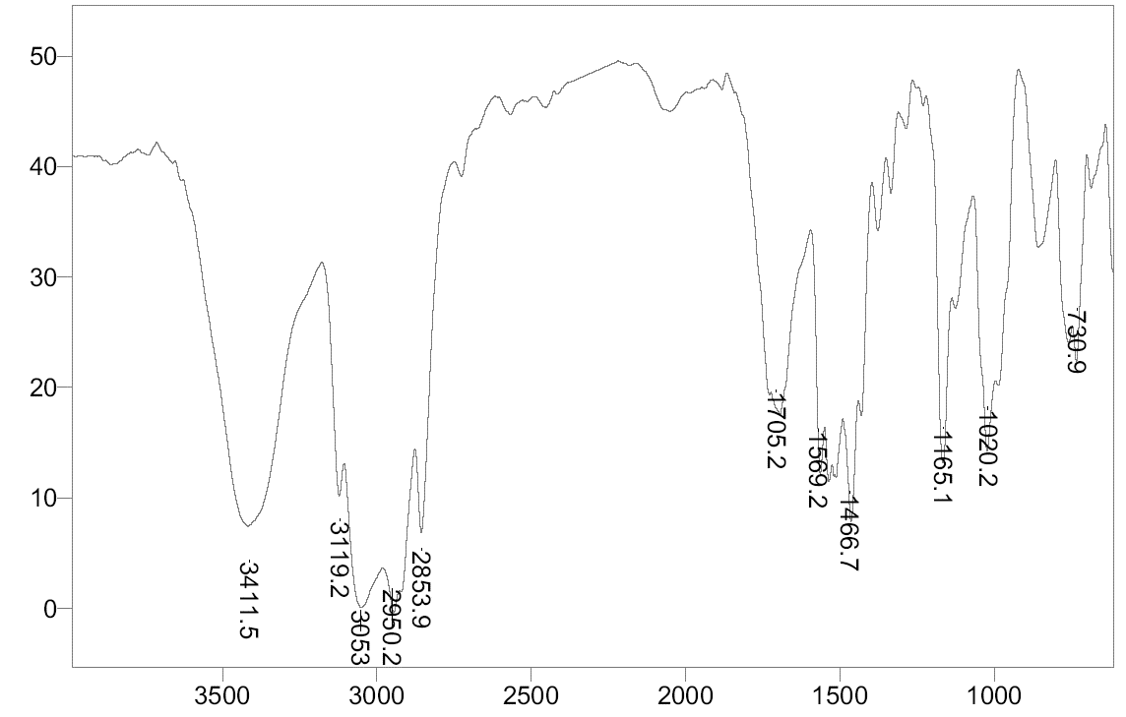
Wavenumber (cm⁻¹)

Transmittance (%)

Fig. S1.FT-IR spectra of 1-propyl-3-methylimidazolium bromide

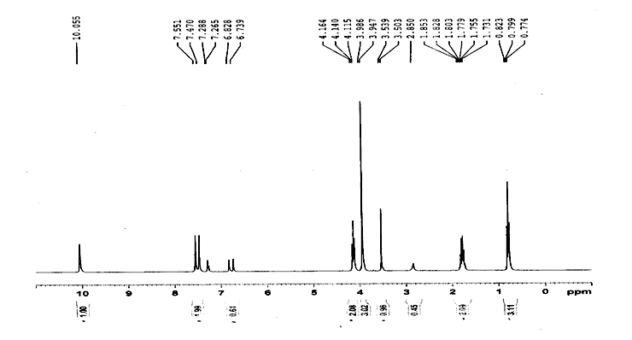

Fig. S2.¹H NMR spectra of 1-propyl-3-methylimidazolium bromide

Figure. S3. The mean activity coefficient for [PrMIm]Br against the molality of [PrMIm]Br in various ethanol–water mixed solvent systems containing 0, 10, 20 and 30% mass fractions of ethanol at 308.2 K. Lines represent Pitzer model according to Eq. (1).

Fig. 1

Figure.S4. The mean activity coefficient for [PrMIm]Br against the molality of [PrMIm]Br in various ethanol–water mixed solvent systems containing 0, 10, 20 and 30% mass fractions of ethanol at 318.2 K. Lines represent Pitzer model according to Eq. (1).

Figure. S5. Temperature comparison of the mean activity coefficient of [PrMIm]Br+ethanol+water mixtures as a function molality concentration of [PrMIm]Br in pure water. Solid lines were generated using Pitzer model.

FigureS6. Temperature comparison of the mean activity coefficient of [PrMIm]Br+ethanol+water mixtures as a function molality concentration of [PrMIm]Br in mass fraction 20% (w_{Ethanol}/w_{mixture}). Solid lines were generated using Pitzer model.

Figure S7. Temperature comparison of the mean activity coefficient of [PrMIm]Br+ethanol+water mixtures as a function molality concentration of [PrMIm]Br in mass fraction 30% (w_{Ethanol}/w_{mixture}). Solid lines were generated using Pitzer model.

