SUPPORTING INFORMATION

KINETIC ANALYSIS OF HYDROLYTIC DECOMPOSITION OF RUBROCURCUMIN ANALOGUES
JEENA JOHN^{1,2}, SUDHA DEVI RUGMINI² and BALACHANDRAN SREEDHARAN NAIR^{2,3}*
¹Department of Chemistry, Christian College, Kattakada, University of Kerala, Thiruvananthapuram.
²Department of Chemistry, Mahatma Gandhi College, University of Kerala, Thiruvananthapuram.
³Principal, NSS College Ottapalam, Kerala, Thiruvananthapuram
E-mail – sbcnair@gmail.com

CONTENTS
Table S1 | Hydrolysis rate data for CBO 1 in different solvent systems | S2
Table S2 | Hydrolysis rate data for CBO 2 in different solvent systems | S2
Table S3 | Hydrolysis rate data for CBO 3 in different solvent systems | S3
Table S4 | Hydrolysis rate data for CBO 4 in different solvent systems | S3
Table S5 | Statistical data for the hydrolysis of CBO analogues in acetone water system obtained from GW plot | S3
Table S6 | Statistical data for the hydrolysis of CBO 1 obtained from GW plots | S4
Table S7 | Statistical data for the hydrolysis of CBO 2 obtained from G W plots | S4
Table S8 | Statistical data for the hydrolysis of CBO 3 obtained from GW plots | S4
Table S9 | Statistical data for the hydrolysis of CBO 4 obtained from GW plots | S5
Figure S1 | The UV-Visible spectrum of CBO 1 in 50 % acetone water medium at 50 °C taken at definite time interval during hydrolysis | S5
Figure S2 | log k₁ vs. mole fraction plots for the hydrolysis of CBO analogues in aqueous acetone medium | S6
Figure S3 | log k₁ vs. mole fraction plots for the hydrolysis of CBO analogues in aqueous acetonitrile medium | S6
Figure S4 | log k₁ vs. mole fraction plots for the hydrolysis of CBO analogues in aqueous acetic acid medium | S7
Figure S5 | log k₁ vs. mole fraction plots for the hydrolysis of CBO analogues in aqueous dioxane medium | S7
Figure S6 | log k₁ vs. mole fraction plots for the hydrolysis of CBO analogues in aqueous methanol medium | S8
Table S1 Hydrolysis rate data for CBO 1 in different solvent systems
% of solvent | 10⁵ k₁ (s⁻¹)
 | Acetone | Acetonitrile | Acetic acid | Dioxane | Methanol
10 | - | - | - | 73.34±0.01 | -
20 | 12.23±0.04 | 27.38±0.02 | 32.76±0.03 | 21.42±0.01 | -
30 | 6.32±0.03 | 10.71±0.02 | 27.05±0.02 | 6.93±0.02 | 62.29±0.03
40 | 3.32±0.03 | 3.42±0.01 | 17.27±0.02 | 2.83±0.01 | 40.76±0.01
50 | 1.76±0.01 | 1.04±0.01 | 12.39±0.01 | - | 28.42±0.04
60 | 1.05±0.01 | 0.43±0.00 | 8.64±0.01 | - | 16.51±0.04

Table S2 Hydrolysis rate data for CBO 2 in different solvent systems
% of solvent | 10⁵ k₁ (s⁻¹)
 | Acetone | Acetonitrile | Acetic acid | Dioxane | Methanol
10 | - | 124.11±0.06 | - | 40.43±0.02 | -
20 | 12.29±0.04 | 15.49±0.01 | 35.64±0.02 | 18.15±0.02 | 88.28±0.03
30 | 6.62±0.02 | 6.29±0.01 | 23.45±0.02 | 6.04±0.01 | 69.58±0.02
40 | 2.64±0.02 | 2.45±0.01 | 17.44±0.01 | 2.43±0.01 | 56.54±0.06
50 | 1.32±0.01 | 1.16±0.02 | 13.20±0.02 | 1.34±0.00 | 33.42±0.01
60 | 0.61±0.01 | - | 9.35±0.01 | - | 22.41±0.02

Table S3 Hydrolysis rate data for CBO 3 in different solvent systems
% of solvent | 10⁵ k₁ (s⁻¹)
 | Acetone | Acetonitrile | Acetic acid | Dioxane | Methanol
10 | - | 87.41±0.02 | - | 48.43±0.01 | -
20 | 11.95±0.03 | 11.12±0.02 | 36.31±0.05 | 15.54±0.02 | 87.51±0.04
30 | 6.33±0.02 | 5.43±0.00 | 23.33±0.01 | 5.64±0.02 | 59.53±0.06
40 | 2.34±0.02 | 2.17±0.01 | 14.44±0.02 | 2.05±0.01 | 42.62±0.03
50 | 0.94±0.01 | 0.88±0.01 | 12.14±0.02 | 0.84±0.01 | 28.36±0.02
60 | 0.43±0.01 | - | 9.55±0.01 | - | 17.28±0.01
Table S4 Hydrolysis rate data for CBO 4 in different solvent systems
% of solvents | 10⁵ k₁ (s⁻¹)
 | Acetone | Acetonitrile | Acetic acid | Dioxane
20 | 24.17±0.06 | - | - | -
30 | 16.09±0.03 | 9.73±0.01 | 19.54±0.02 | 14.24±0.01
40 | 8.50±0.03 | 6.38±0.01 | 15.27±0.01 | 10.37±0.02
50 | 4.68±0.02 | 4.40±0.02 | 10.58±0.01 | 7.19±0.01
60 | 2.88±0.02 | 3.22±0.01 | 8.38±0.00 | 5.68±0.01

Table S5 Statistical data for the hydrolysis of CBO analogues in acetone water system obtained from GW plot
 | CBO 1 | CBO 2 | CBO 3 | CBO 4
Slope | 0.3815 | 0.4704 | 0.5296 | 0.3389
Intercept | 4.6066 | 4.3030 | 4.0809 | 5.1044
SD | 0.0402 | 0.0254 | 0.0278 | 0.0180
R² | 0.9966 | 0.9991 | 0.9992 | 0.9991

Table S6 Statistical data for the hydrolysis of CBO 1 obtained from GW plots
 | Acetone | Acetonitrile | Acetic acid | Dioxane | Methanol
Slope | 0.3815 | 0.9919 | 0.4136 | 0.7345 | 0.4491
Intercept | 4.6066 | 3.5616 | 5.3000 | 3.9332 | 5.5534
SD | 0.0402 | 0.1051 | 0.0237 | 0.0545 | 0.0169
R² | 0.9966 | 0.9923 | 0.9963 | 0.9974 | 0.9984
Table S7 Statistical data for the hydrolysis of CBO 2 obtained from G W plots
 | Acetone | Acetonitrile | Acetic acid | Dioxane | Methanol
Slope | 0.4704 | 0.8300 | 0.3880 | 0.5929 | 0.3931
Intercept | 4.3030 | 3.7923 | 5.3664 | 4.2570 | 5.7686
SD | 0.0254 | 0.0312 | 0.0292 | 0.0690 | 0.0293
R² | 0.9991 | 0.9994 | 0.9936 | 0.9952 | 0.9945

Table S8 Statistical data for the hydrolysis of CBO 3 obtained from GW plots
 | Acetone | Acetonitrile | Acetic acid | Dioxane | Methanol
Slope | 0.5296 | 0.8039 | 0.3940 | 0.6812 | 0.4474
Intercept | 4.0809 | 3.7549 | 5.3393 | 3.9641 | 5.5666
SD | 0.0278 | 0.0204 | 0.0518 | 0.0353 | 0.0177
R² | 0.9992 | 0.9997 | 0.9809 | 0.9990 | 0.9984

Table S9 Statistical data for the hydrolysis of CBO 4 obtained from GW plots
 | Acetone | Acetonitrile | Acetic acid | Dioxane
Slope | 0.3389 | 0.3365 | 0.3320 | 0.2087
Intercept | 5.1044 | 5.1555 | 5.4059 | 5.5924
SD | 0.0180 | 0.0213 | 0.0221 | 0.0167
R² | 0.9991 | 0.9965 | 0.9939 | 0.9970

Figure S1. The UV-Visible spectrum of CBO 1 in 50 % acetone water medium at 50 °C taken at definite time interval during hydrolysis

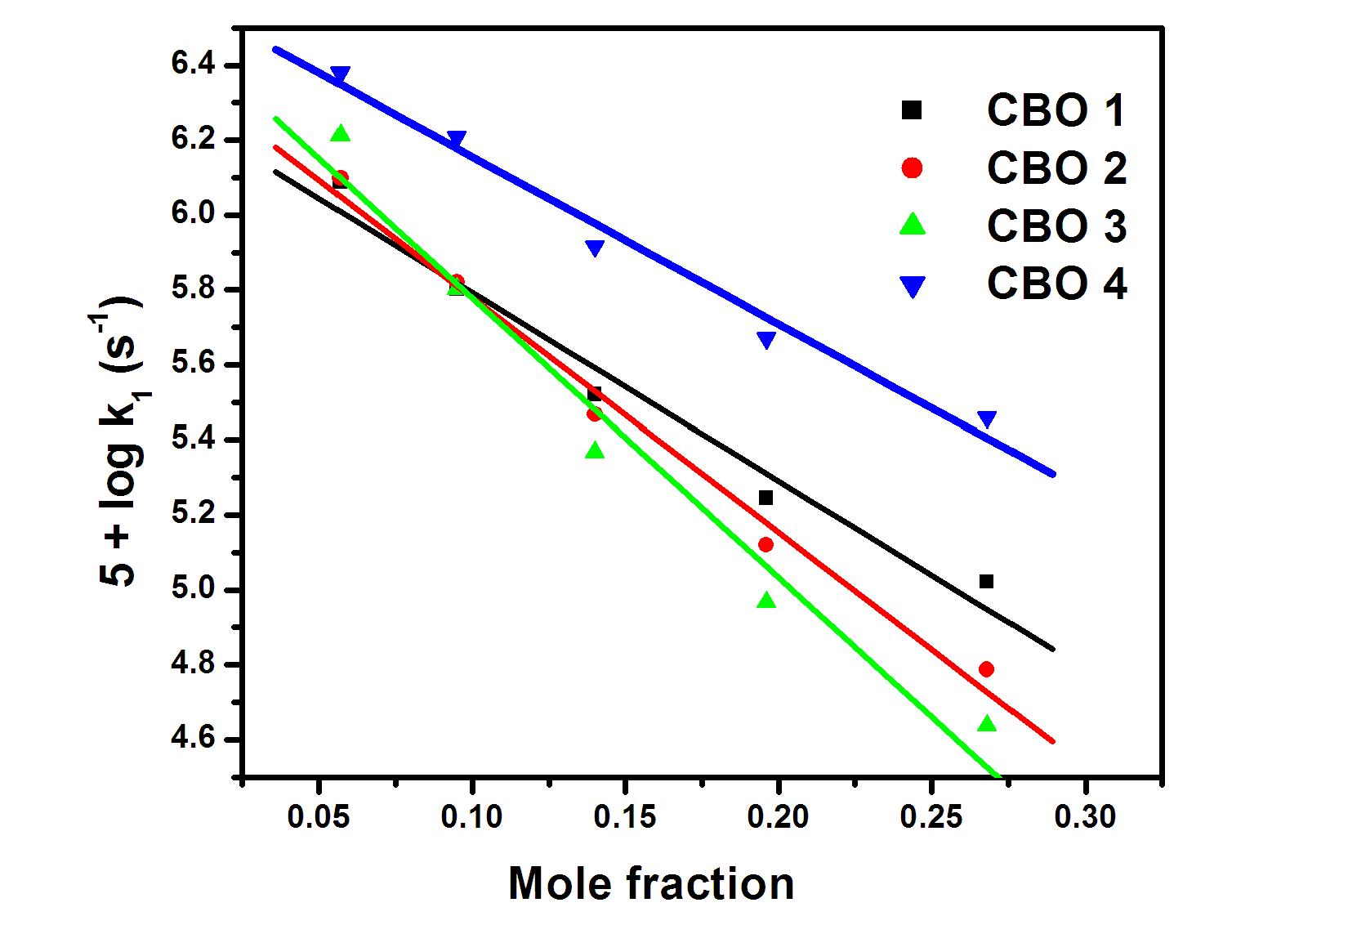
Fig. S2 log k₁ vs. mole fraction plots for the hydrolysis of CBO analogues in aqueous acetone medium

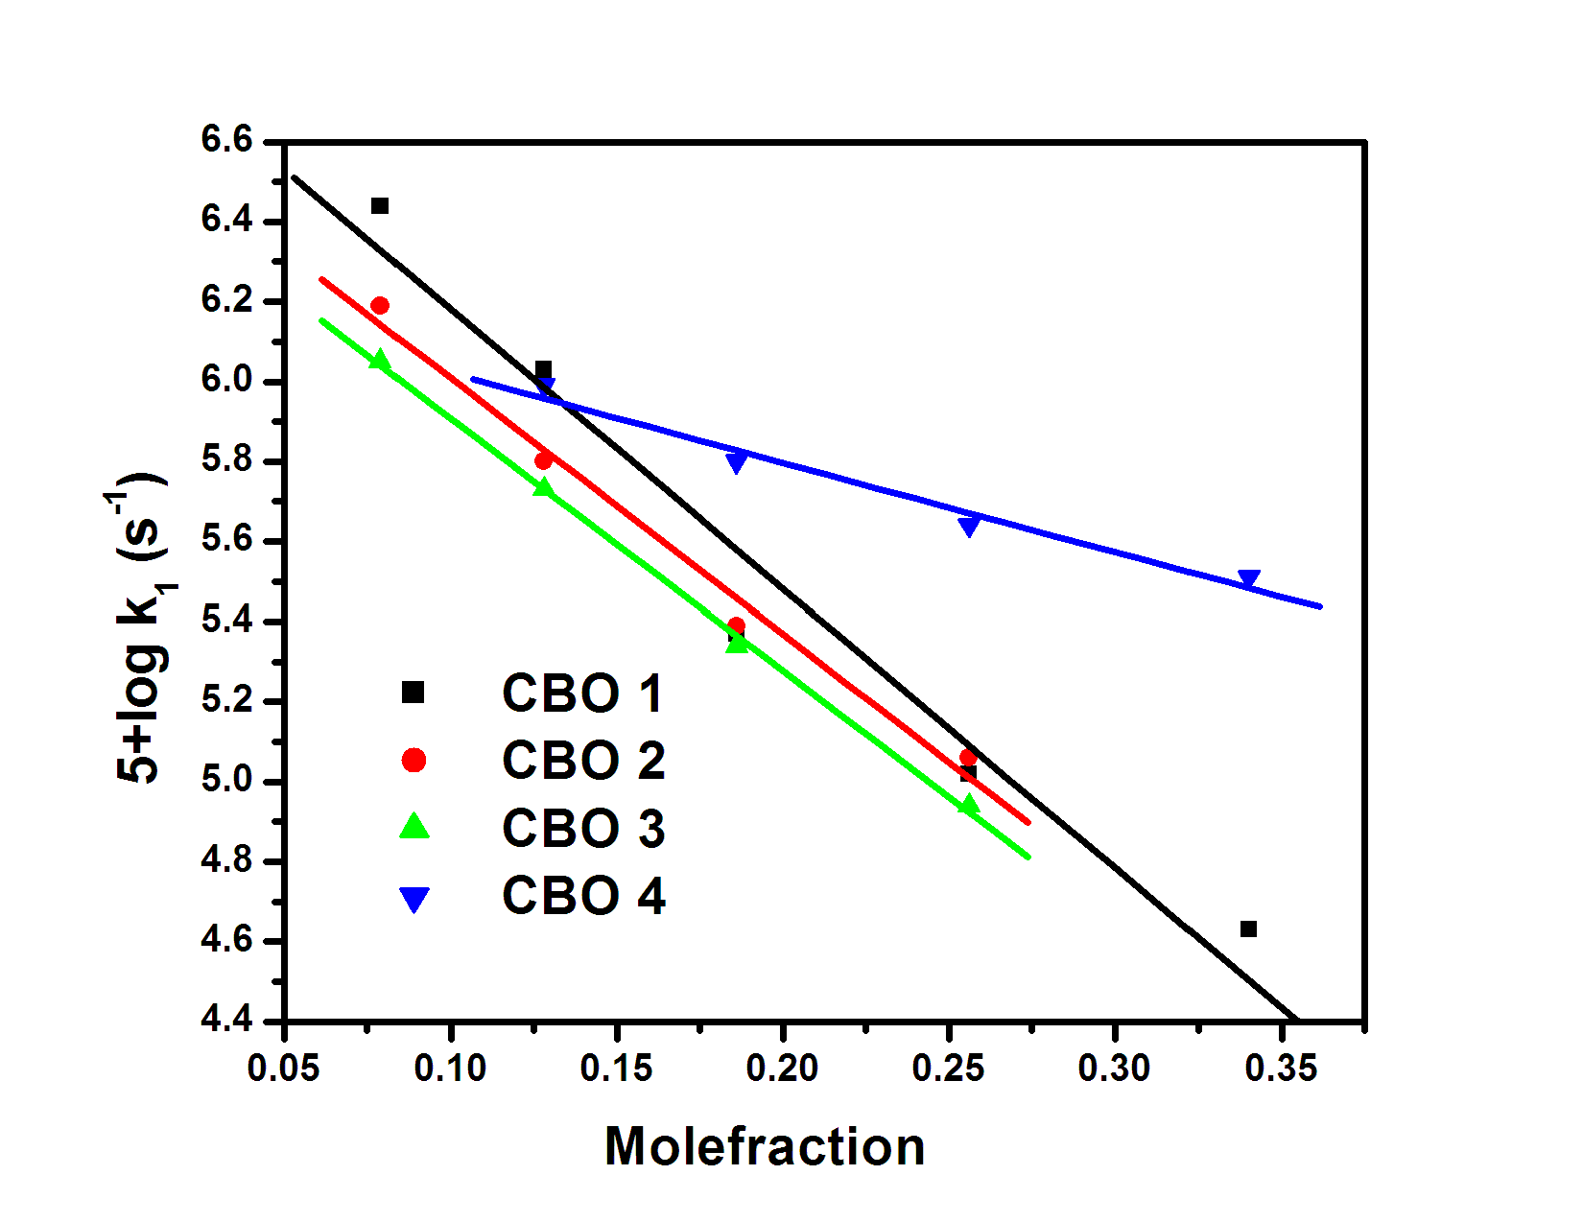
Fig. S3 log k₁ vs. mole fraction plots for the hydrolysis of CBO analogues in aqueous acetonitrile medium

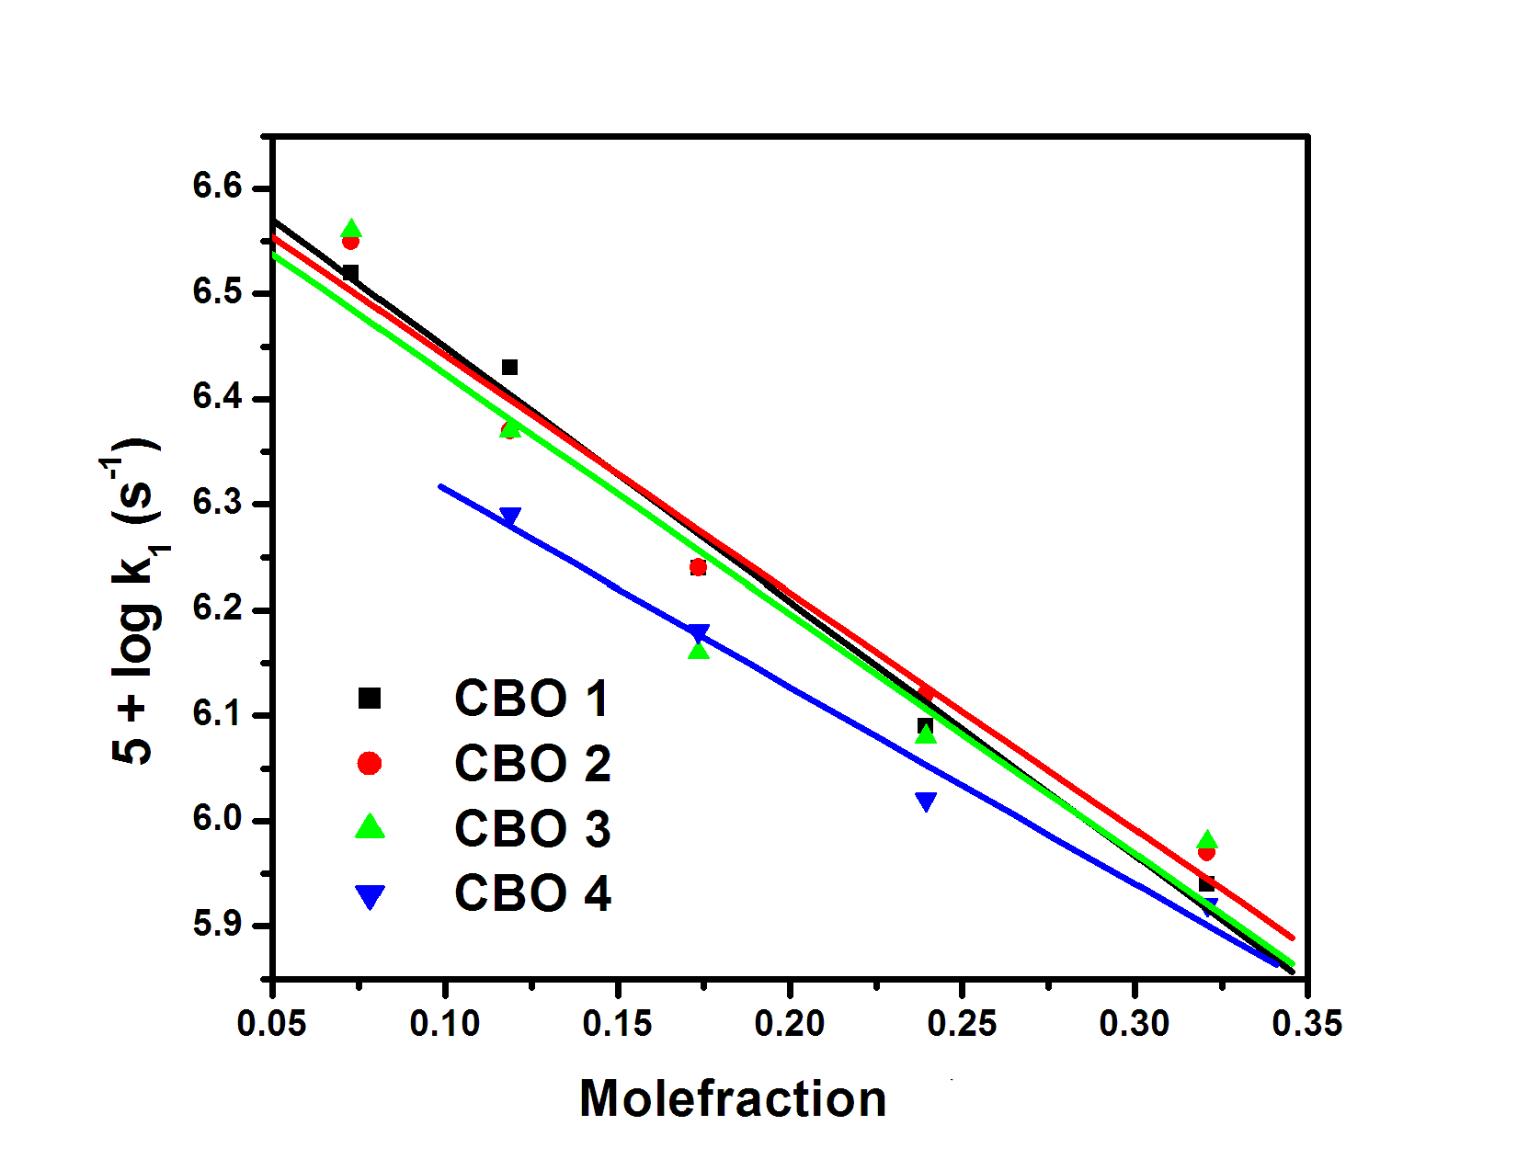
Fig. S4 log k₁ vs. mole fraction plots for the hydrolysis of CBO analogues in aqueous acetic acid medium
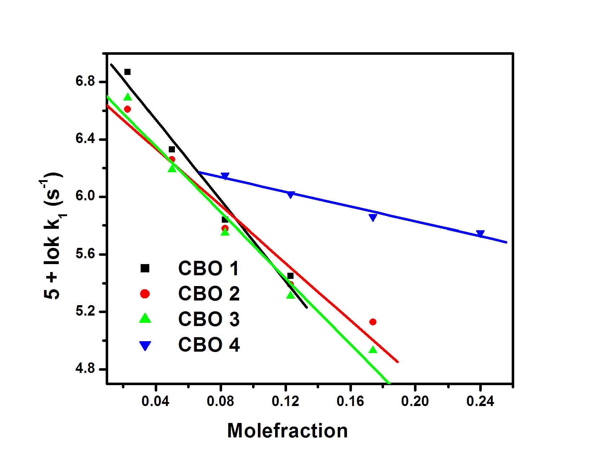
Fig. S5 log k₁ vs. mole fraction plots for the hydrolysis of CBO analogues in aqueous dioxane medium
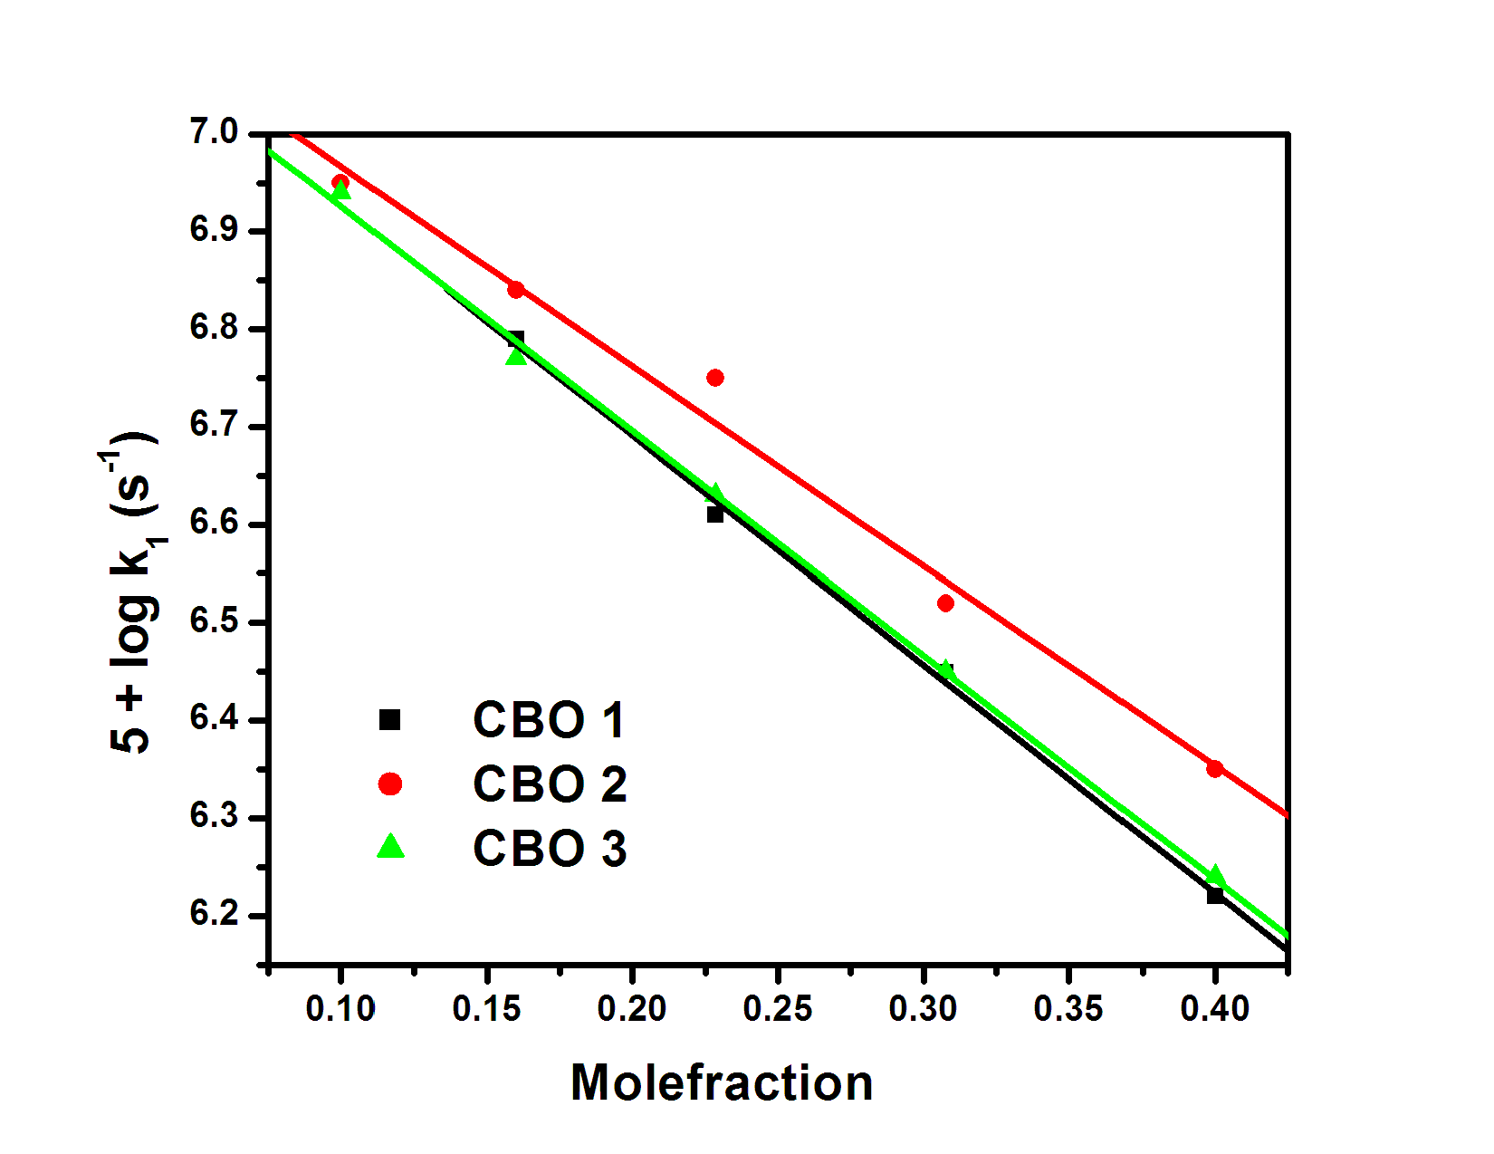
Fig. S6 log k₁ vs. mole fraction plots for the hydrolysis of CBO analogues in aqueous methanol medium

