Supplementary Section

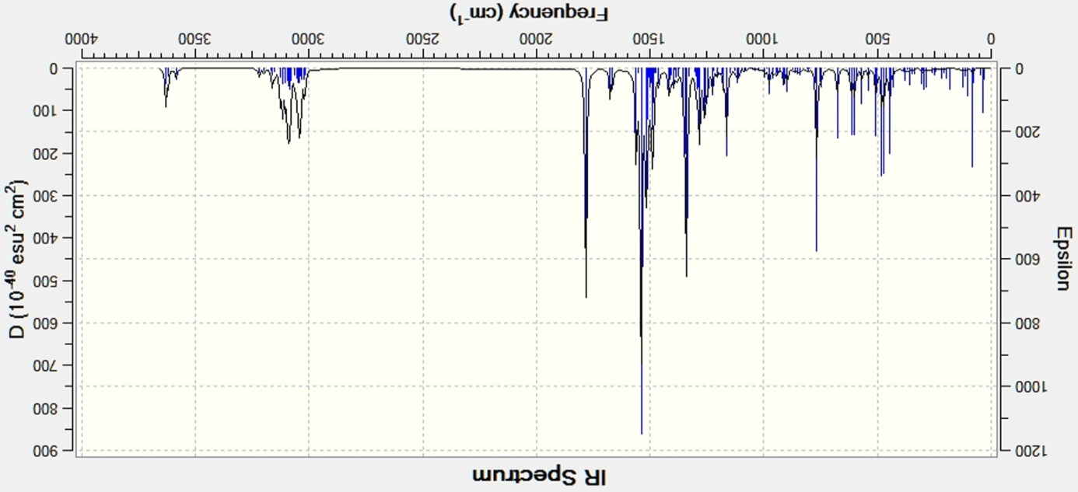

M06-2X

Fig. 1S. Calculated IR spectra for 5.

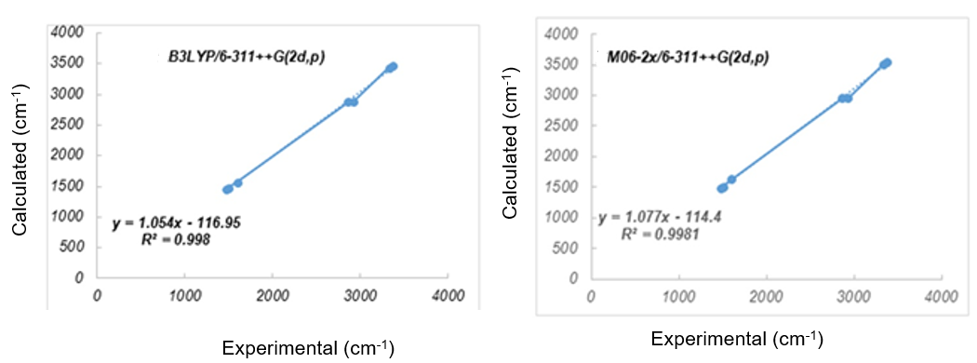
Fig. 2S. Relationship between the experimental and computed frequencies of 5.

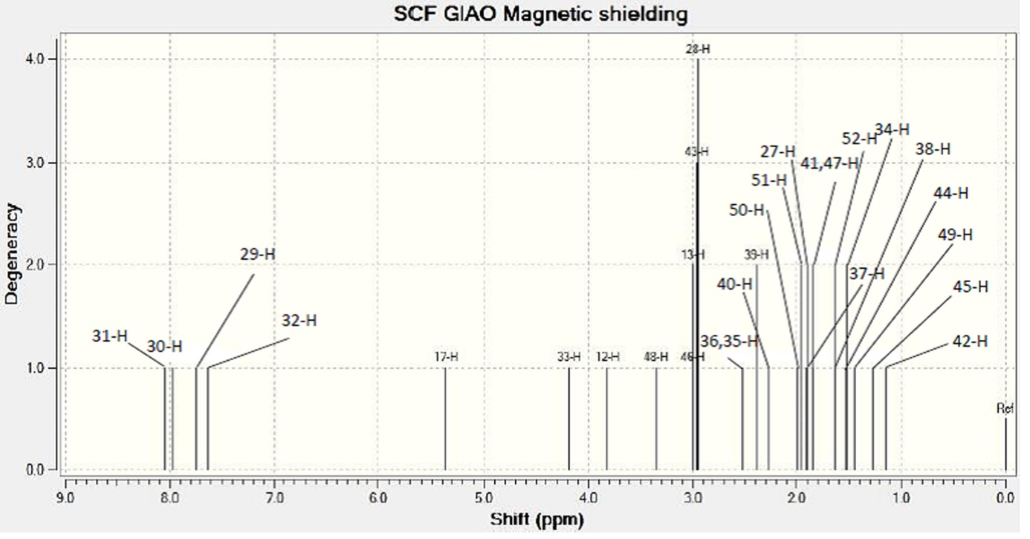
M06-2X

Fig. 3S. Calculated ¹H NMR spectra of 5.

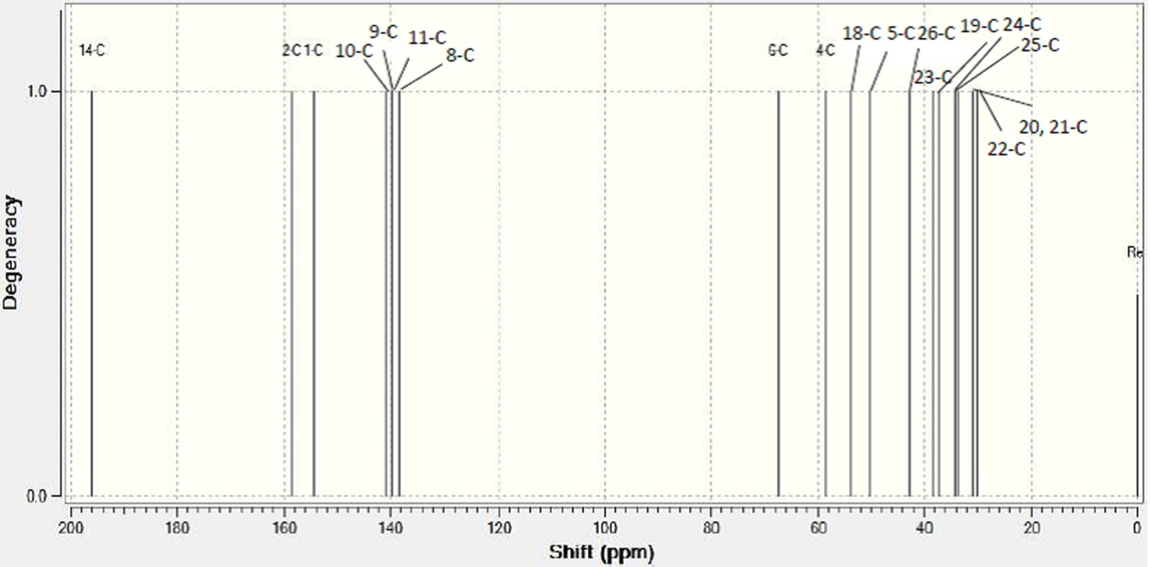

M06-2X

Fig. 4S. Calculated ¹³C NMR spectra of 5.

Table. 1S. Theoretically computed total energies (kcal.mol⁻¹), zero-point vibrational energies (kcal.mol⁻¹), rotational constants (GHz), entropies (cal.mol⁻¹.K⁻¹), enthalpies (kcal. mol⁻¹), Gibbs-free energies (kcal. mol⁻¹), dipole moment (Debye) and some physico-chemical properties at M06-2X/6-311++G(2d,p) level.
Parameters | M06-2X/6-311++G(2d,p)
Total energy | -615494.160
Zero-point energy | -615203.373
Rotational constants | 0.4720513
 | 0.1377180
 | 0.1148729
Entropy
Total | 152.187
Translational | 43.140
Rotational | 34.992
Vibrational | 74.055
Enthalpy | -615189.141
Gibbs-free energy | -615234.515
Dipole moment (D)
X | -1.8788
Y | -0.6383
Z | 1.9260
Total | 2.7653
Properties | Values
Molar Refractivityª (cm³) | 93.92 ± 0.4
Molar Volumeª (cm³) | 286.2 ± 5.0
Parachorª (cm³) | 744.2 ± 6.0
Index of refractionª | 1.570 ± 0.03
Surface tensionª (dyne/cm) | 45.7 ± 5.0
Densityª (g/cm³) | 1.10 ± 0.1
Polarizabilityª (cm³) | 37.23 ± 0.5 ×10⁻²⁴
Log P | 2.37^{b}
ªACD/ChemSketch, ^{b}ChemBioOffice Ultra

Table. 2S. Second order perturbation theory analysis of Fock Matrix in NBO basis for 5 at the M06/2X method with 6-311++G(2d,p) basis set.
Donor NBO(I) | Acceptor NBO(j) | E2(kcal/mole)  M06-2x |  | Ej-Ei(a.u)  M06-2x |  | F(i,j)(a.u)  M06-2x
π(C1-C2) | π*(C9-C8) |  | 31.68 |  | 0.32 |  | 0.091
π(C1-C2) | π*(C10-C11) |  | 28.38 |  | 0.35 |  | 0.090
π(C8-C9) | π*(C1-C2) |  | 25.34 |  | 0.21 |  | 0.068
π(C8-C9) | π*(C10-C11) |  | 27.22 |  | 0.35 |  | 0.089
π(C10-C11) | π*(C1-C2) |  | 30.90 |  | 0.26 |  | 0.083
π(C10-C11) | π*(C8-C9) |  | 28.10 |  | 0.32 |  | 0.087
Lp(1)N3 | π*(C1-C2) |  | 74.67 |  | 0.36 |  | 0.157
Lp(1)N3 | σ*(C4-C24) |  | 7.79 |  | 0.82 |  | 0.074
Lp(1)N7 | σ*(C4-C26) |  | 16.05 |  | 2.60 |  | 0.189
Lp(1)N15 | π*(C14-O16) |  | 71.25 |  | 0.40 |  | 0.150
Lp(1)N15 | σ*(C18-C23) |  | 7.63 |  | 0.77 |  | 0.073
Lp(2)O16 | σ*(C14-N15) |  | 31.02 |  | 0.86 |  | 0.147
Lp(2)O16 | σ*(C6-C14) |  | 23.40 |  | 0.76 |  | 0.121

